

**BONAFIDE CERTIFICATE**

This is to certify that record of course work is a bonafide work done by

Nandanoori Vishnu Vardhan Reddy ID No.: 2015UG02020, in partial fulfilment of requirements for the 3rd year BSc (Hons) Game Design & Development during the academic year 2017 – 2018 is the original work of the candidate.

Submitted for the **Specialist Practice - IV** assessment held on

______________.

_______________ _______________

**Verified By Staff In-Charge**

**Design Document**

BY

Nandanoori Vishnu Vardhan Reddy

L6 Game Design and Development

Specialist Practice - IV

**ICAT design & Media College**

**15UG02020**

# Game Concept: -

The game is about stealing money from different houses without being detected by the owner of the house.

# Game Overview: -

Game Genre:The game is of Stealth genre.

Game view: First person

Game Theme: The back drop of the game is set to dark and cartoonish.

Gameplay:The protagonist of the game is a thief who robs money of different houses. At the start the player is placed in a street with three houses, each house is a different level. The player can roam around the environment and select a house to rob. To enter the house the player must go to the door of the house and press “E” key. A soon as the player enter the house, he should try to find as much money as possible by searching the house. The player can interact with doors, drawers, cupboards etc. After robbing the house, the player can leave the house by going to the door he can in and press “E” and the continue to another house to rob.

Player Controls:The player has common controls which are: W, A, S, D for movement and “E” to interact with the objects. Look and Feel of the game: -

The objects in the game are cartoonish and abstract without proper dimensions and is dark as the protagonist is a thief and mostly thief set out to rob during nights. The objects in the game are abstract and zig-zag without straight lines. Different levels of the game: -

The game has 3 level or houses which can be chosen from a level transition scene, which is a Street. The player will be first spawned in level transition scene and then the one level out of three can be chosen. To switch between levels, the player will first come level transition scene and then can select the next level. There is no particular order to play the three levels of the game, the player can choose any level he want.

Level transition Scene:The level transition scene consists of 3 houses, 17 trees, 8 street lamps and some grass. The 3 houses in the scene represent 3 levels in the game and pressing “E” in front of their doors will take the player to respective scene.

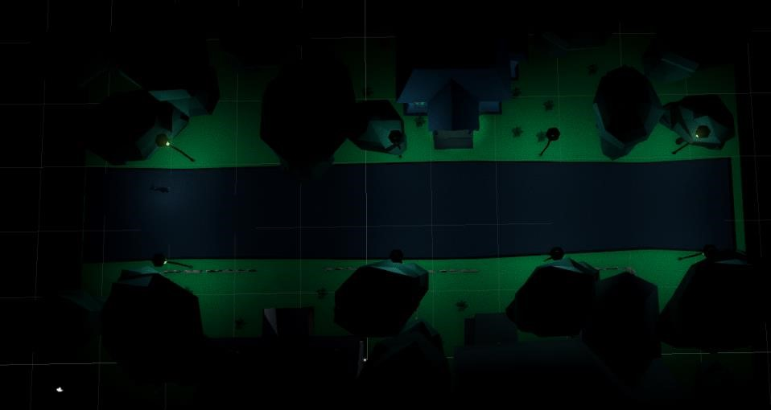

Top view of Level transition scene with lighting effects

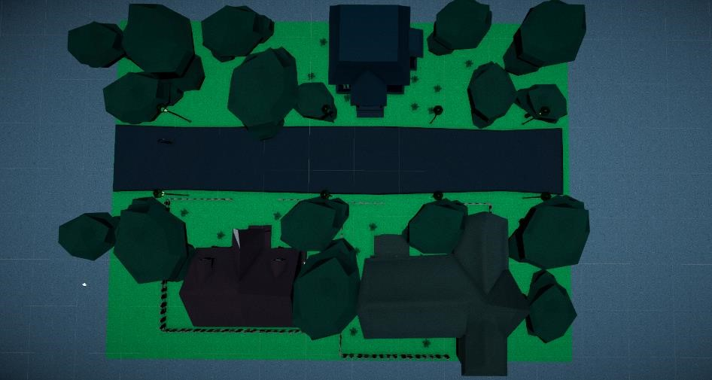

Top view of Level transition scene without lighting effects

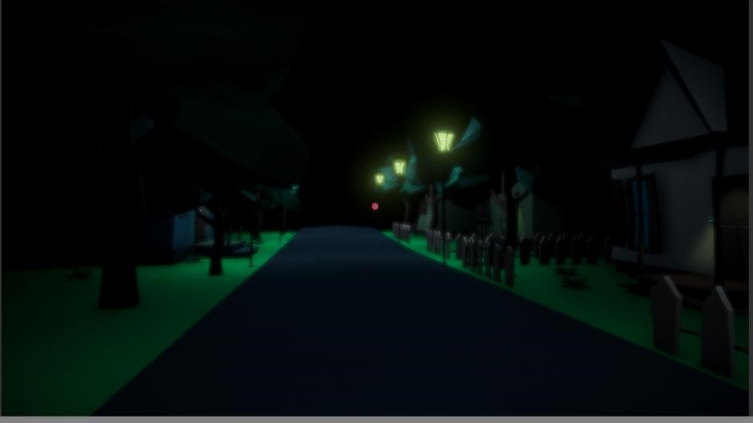

Player perspective of the Level transition scene

Level 1:Level 1 can be played by pressing “E” in front of the door of the house to the left of the player. The level contains 2 rooms a living cum kitchen and a bathroom. The level has no NPC, and an amount of “385” can be collected in this level.

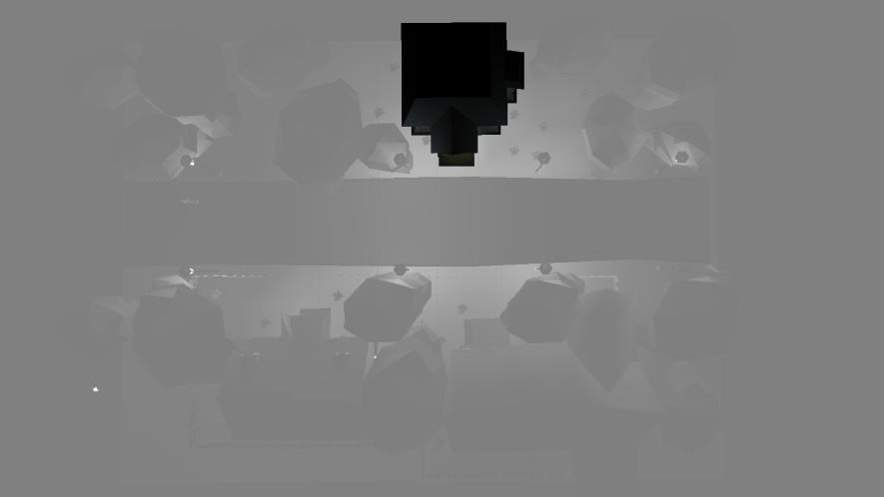

The placement of the house exterior of level one in Level transition scene

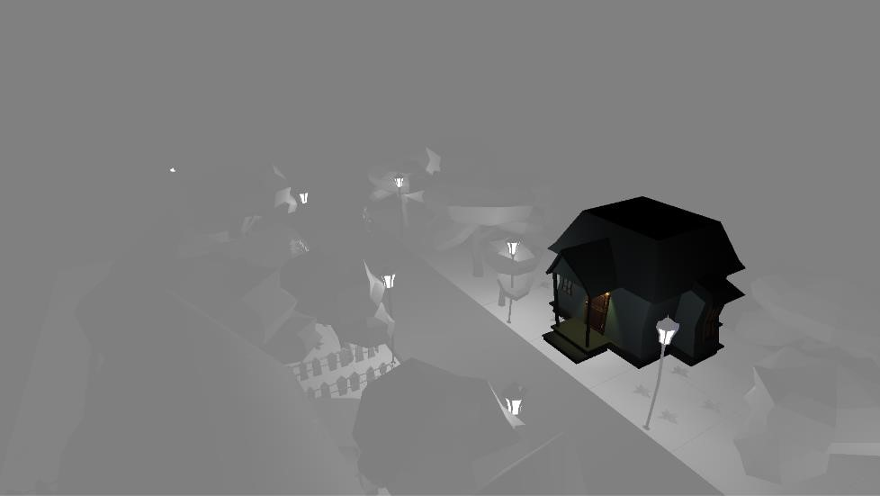

Perspective view of the exterior of level one



Colour pallet of the exterior house of Level 1

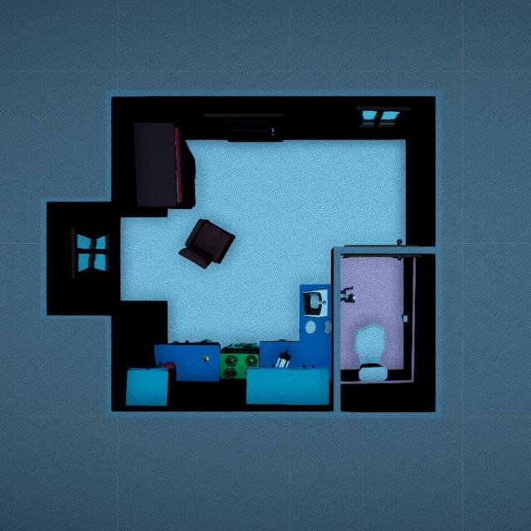 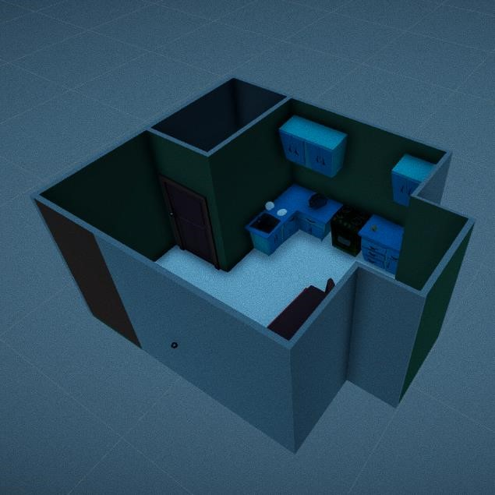

top view of level one perspective view of level one



Colour pallet of the interior walls of Level 1

Level 2:Level 2 can be played by pressing “E” in front of the 2nd house to the right of the player. The level has 4 rooms, a living room, bedroom, kitchen and bathroom. The level contains a NPC sitting on the sofa of the living room watching TV. The level also has a locker to the left of the NPC. Money in locker has more value than the money found in the house normally. To open the locker and collect the money, key of the locker should be found, which can be found by searching the house. In this level the key can be found in the top door of the fridge. Going to the locker without distracting the NPC will get us caught. The NPC can be distracted by throwing objects which can be taken. Throwing an object will the make the NPC to the place where it is thrown and place it where it used to be, in this time game the player should open the locker and collect the money in it. An amount of “2840” can be collected in this level.

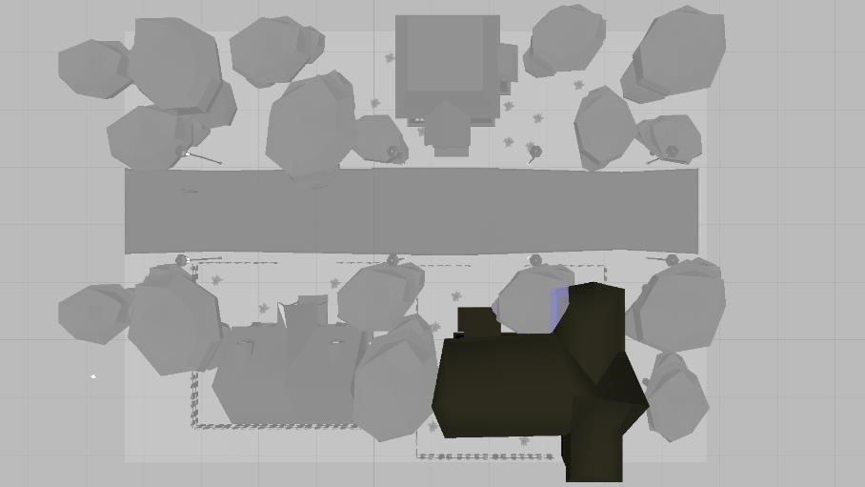

The placement of the house exterior of level two in Level transition scene

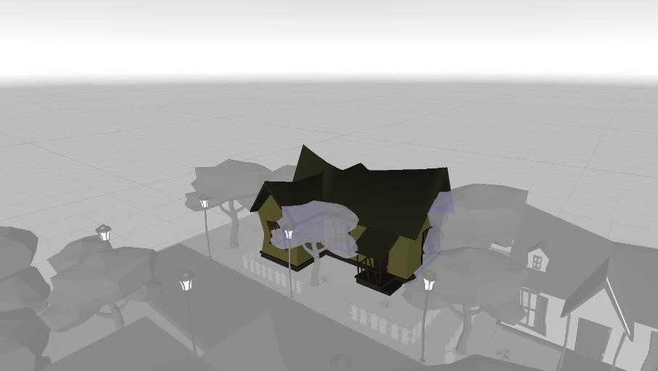

Perspective view of the exterior of level two



Colour pallet of the exterior house of Level 2

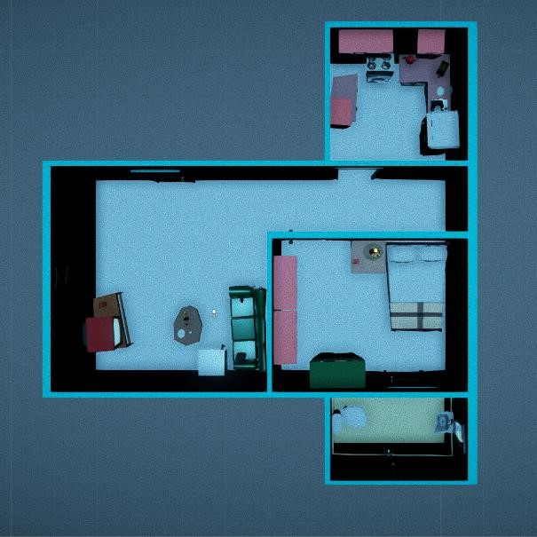 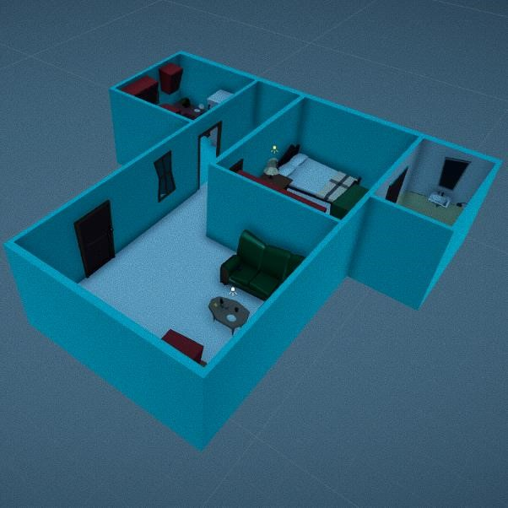

top view of level 2 perspective view of level 2



Colour pallet of the interior walls of Level 2

Level 3:Level 3 can be played by pressing “e” key in front of the 1st house to the left of the player. The house contains 4 rooms, a living room, bedroom, bathroom and a kitchen. The level has a NPC who will be sleeping in the bedroom. The level also has a locker in the cupboard in the bedroom. Similar to level 2, if the player directly approaches to the locker, will end up being caught. The NPC should be first distracted to acquire the key to the locker as it is under the pillow on the bed. Then the player should hide in the bathroom till the NPC goes back to sleep and then collect the money from the locker. Player can collect an amount up to “2210” in this level.

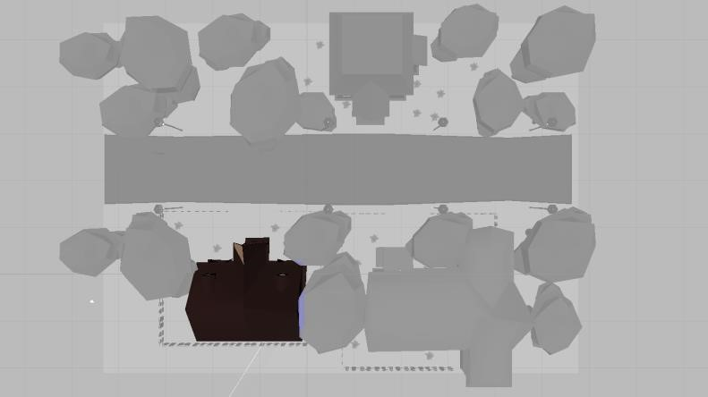

The placement of the house exterior of level three in Level transition scene

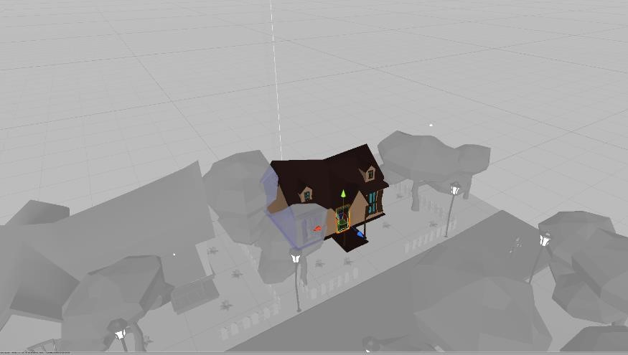

Perspective view of the exterior of level three



Colour pallet of the exterior house of Level 3

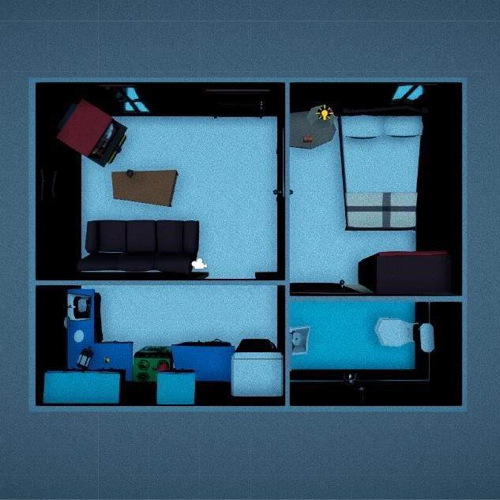 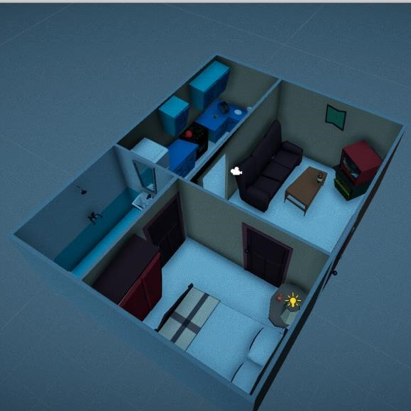

top view of level 3 perspective view of level 3



Colour pallet of the interior walls of Level 3

# Characters: -

There are three character in the game on the protagonist, who is a thief, second on is the owner of the 2nd house and the third the owner of the 3rd house. The character and other models are modelled, skinned and rigged in Maya and are animated in Unity animator. The models of the three characters are the same with variations. As the protagonist is a thief, he will be wearing black full hands T-shirt and pant with a beanie cap and mask. The second character will be wearing Yellow T shirt and Blue short and the third character will be wearing Red T shirt with blue shorts.

Protagonist:

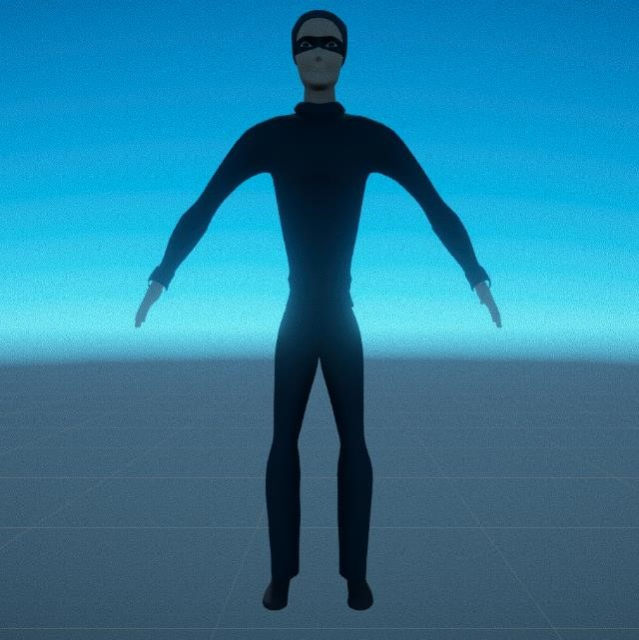 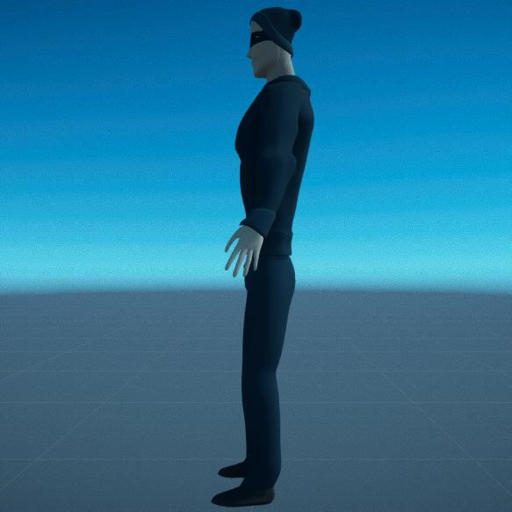

The front and side view of the Protagonist



The colours used in texturing the player

2nd Character:

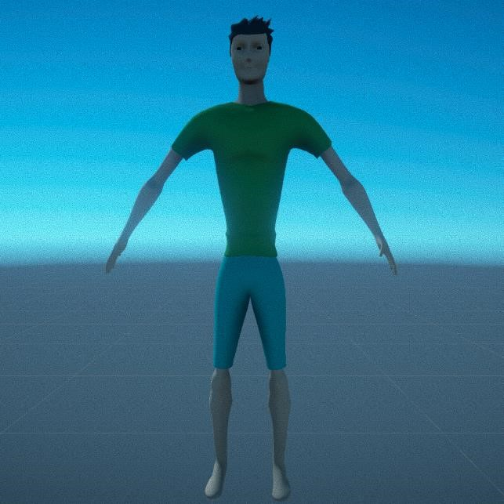 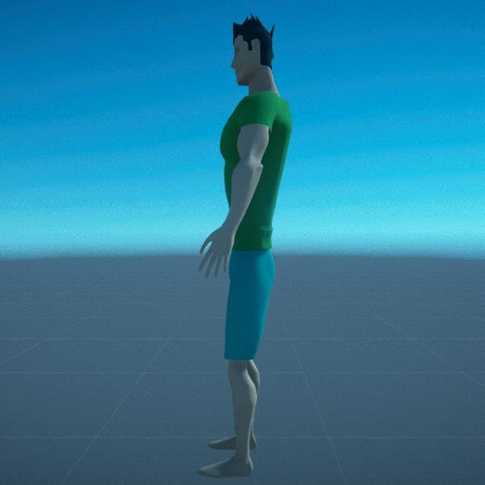

The front and side view of the 2nd character (owner of the 2nd house)



The colours used in texturing the 2nd character

3rd character:

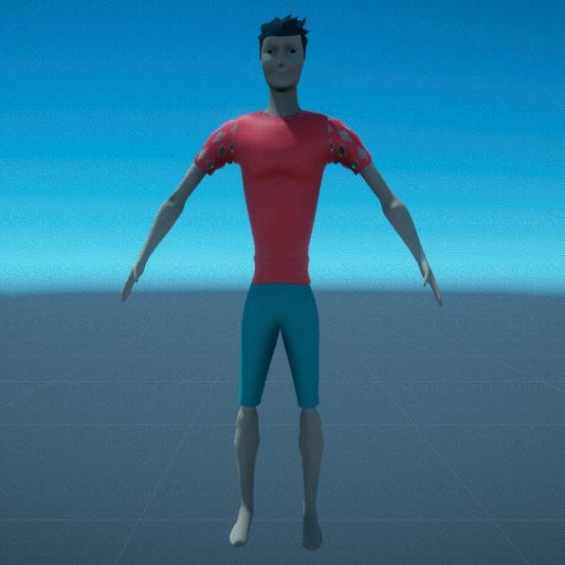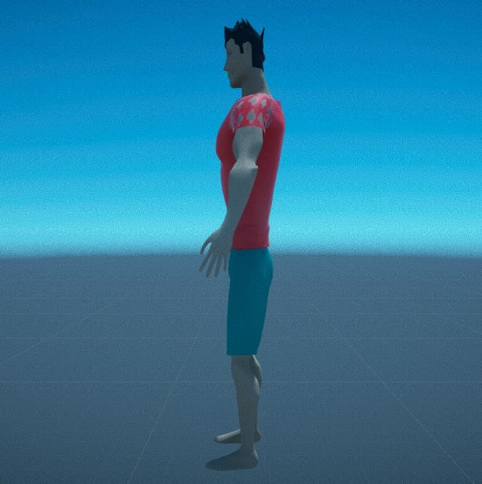

The front and side view of the 3rd character (owner of the 3rd house)



The colours used in texturing the 3rd character

# Assets in the game: -

The game has four different types of objects, which are take able, cash, intractable and non-intractable objects. The take able can be picked up and thrown, generally used to distract the NPC. The cash is the many objective of the game, the player should collect as much cash as possible from a house. The intractable object (generally doors, Cupboard, drawer and shelves) can be opened and closed to check for money. Player cannot interact with non- intractable objects (objects like TV, Sofa, Chair).

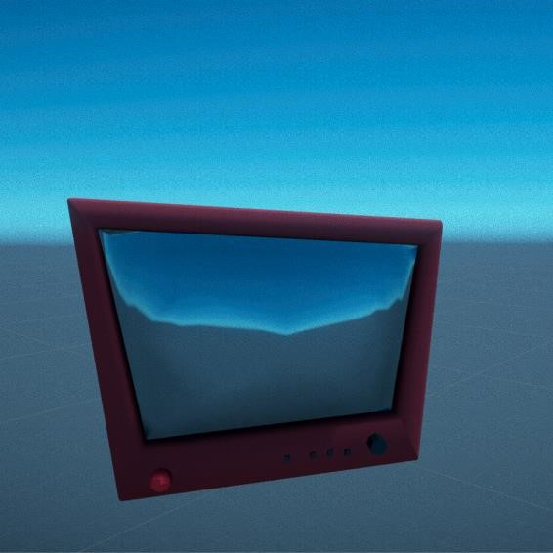 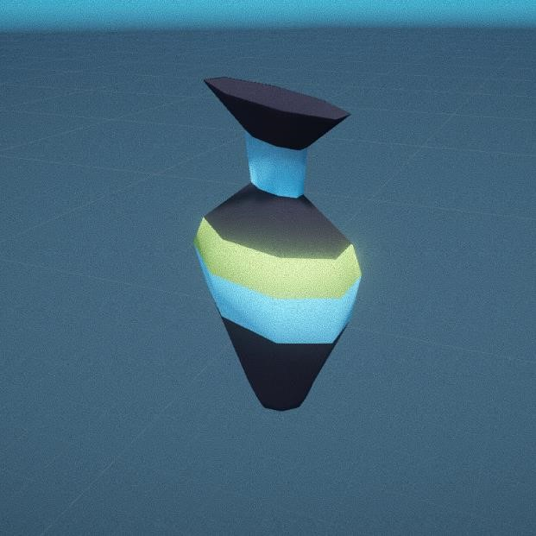

Name: TV Name: Vase

Levels used in: L1, L2 Levels used in: L1, L2

Type: Non-Intractable Type: Intractable

Colour pallets:  L1,L2 Colour pallets: L2

L1



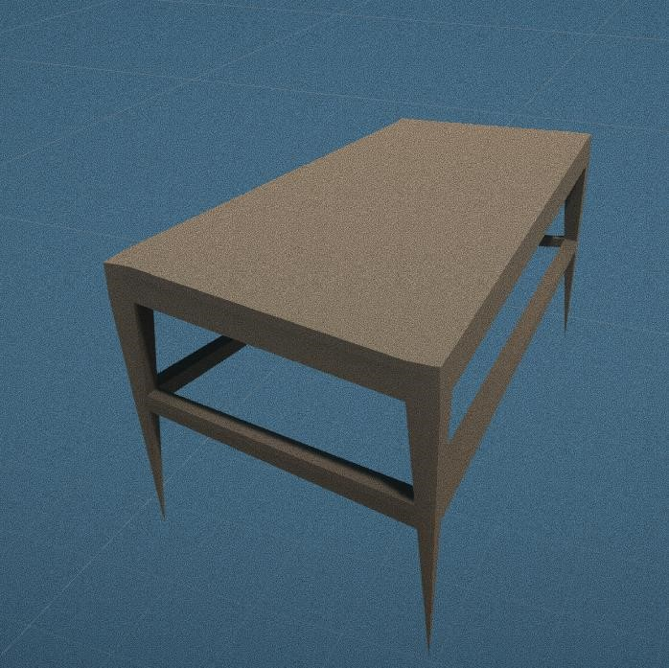 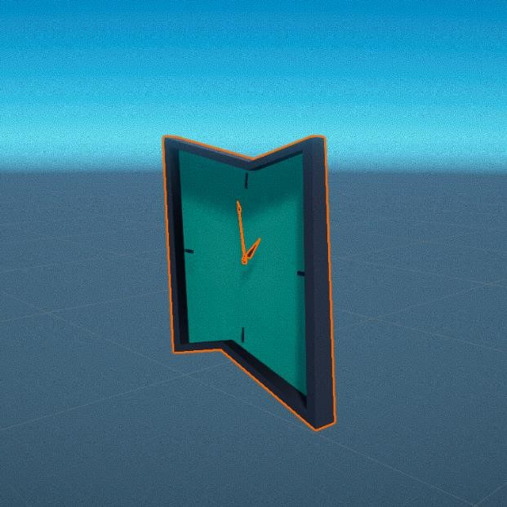

Name: Table Name: wall clock

Levels used in: L1, L2 Levels used in: L1, L2

Type: Non-Intractable Type: Non-Intractable

Colour pallets:  L1,L2 Colour pallets: L1, L2

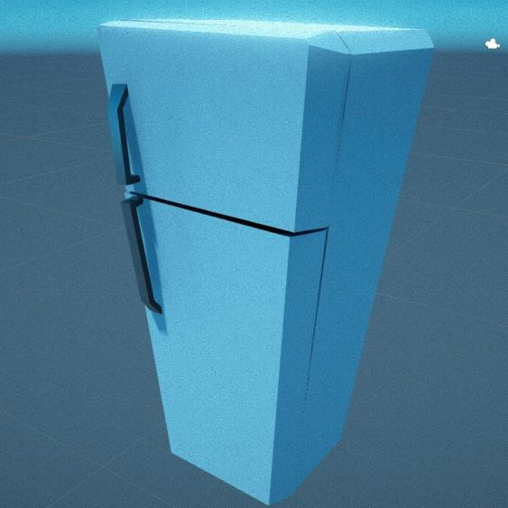 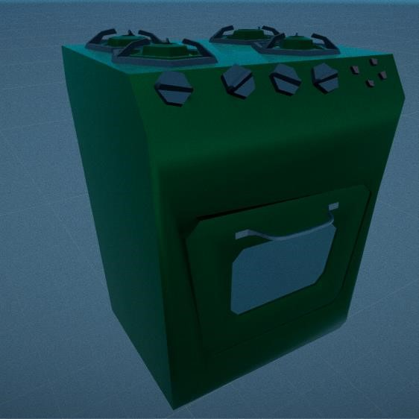

Name: fridge Name: Oven

Levels used in: L1, L2 Levels used in: L1, L2, L3

Type: Intractable Type: Non-Intractable

Colour pallets: L1, L2 Colour pallets: L3

L1

L2



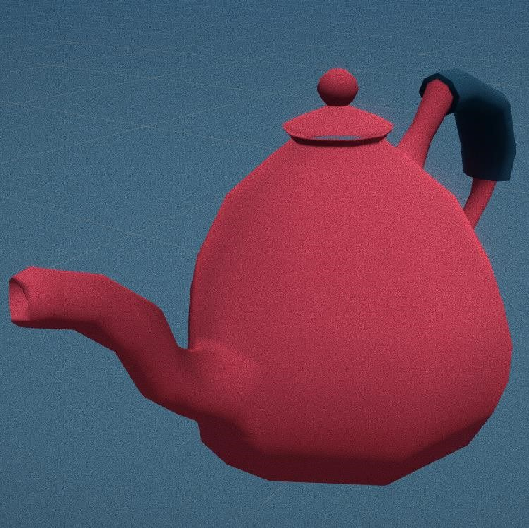 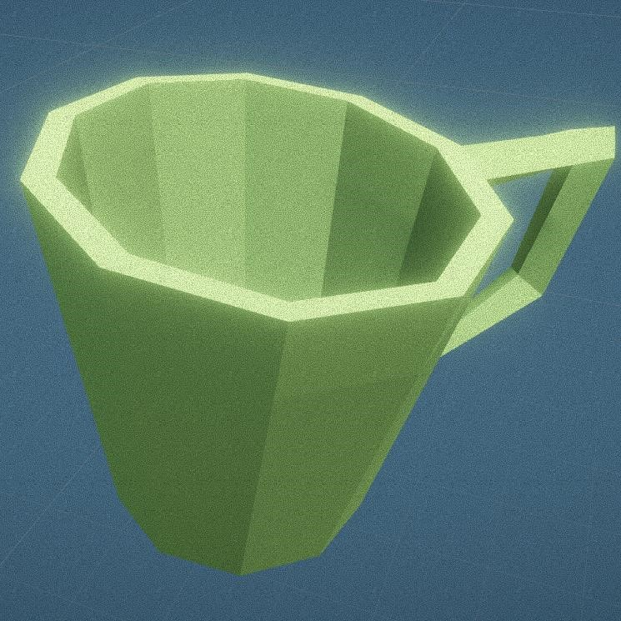

Name: Kettle Name: Tea cup

Levels used in: L1, L2, L3 Levels used in: L1, L2, L3 Type: Intractable Type: Intractable

L1, L2, L3

Colour pallets:



L1,

L2, L3

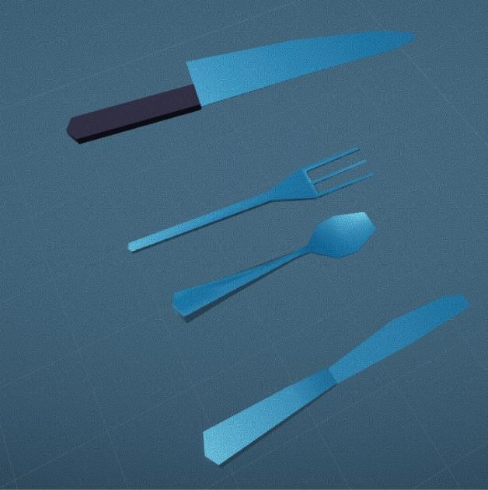

Colour pallets:

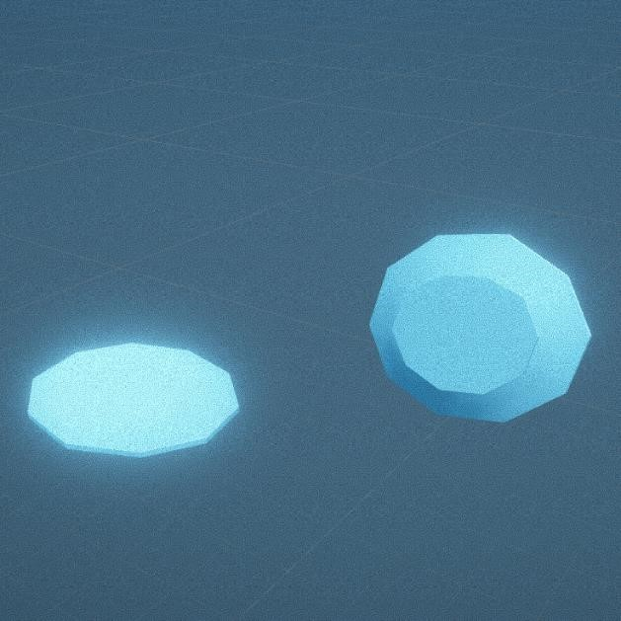

Name: plates Name: Kitchen Set

Levels used in: L1, L2, L3 Levels used in: L1, L2, L3

Type: Intractable Type: Intractable

Colour pallets:  L1, L2, L3 Colour pallets:  L1, L2, L3

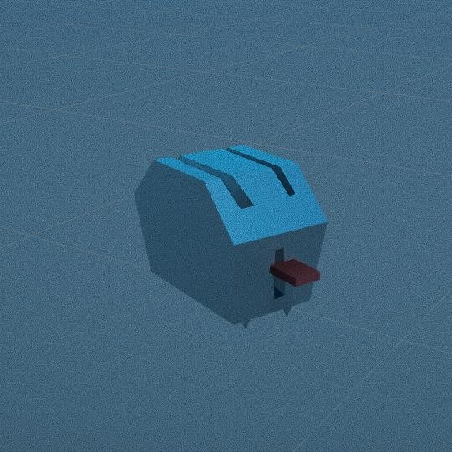 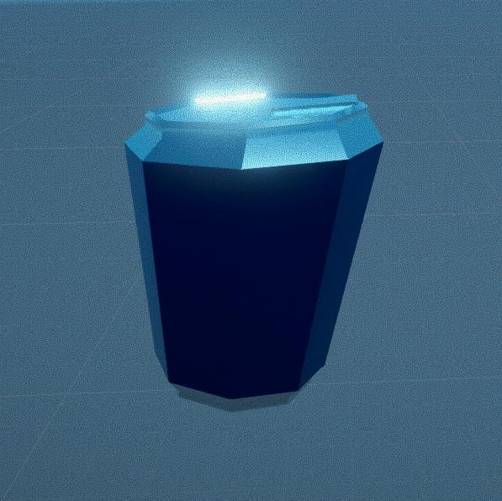

Name: Toaster Name: Tin can

Levels used in: L1, L2, L3 Levels used in: L1, L2

Type: Intractable Type: Intractable

Colour pallets: L1 L3 Colour pallets:  L1, L2

L2



 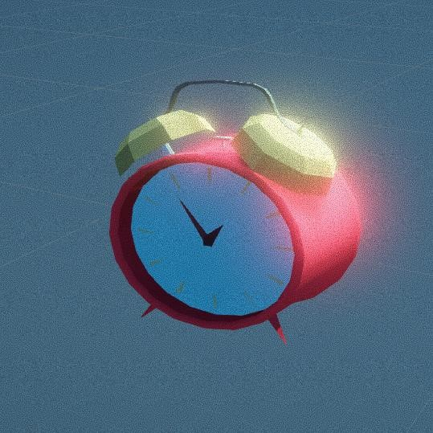

Name: Bed Lamp Name: Alarm clock

Levels used in: L1, L2 Levels used in: L1, L2

Type: non- Intractable Type: Intractable

Colour pallets: L1, L2 Colour pallets:  L1, L2

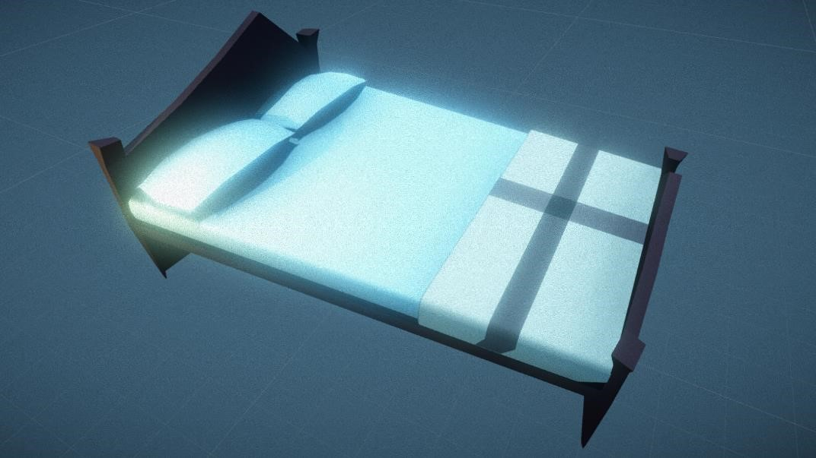

Name: Bed

Levels used in: L1, L2

Type: non- Intractable

Colour pallets: L1, L2

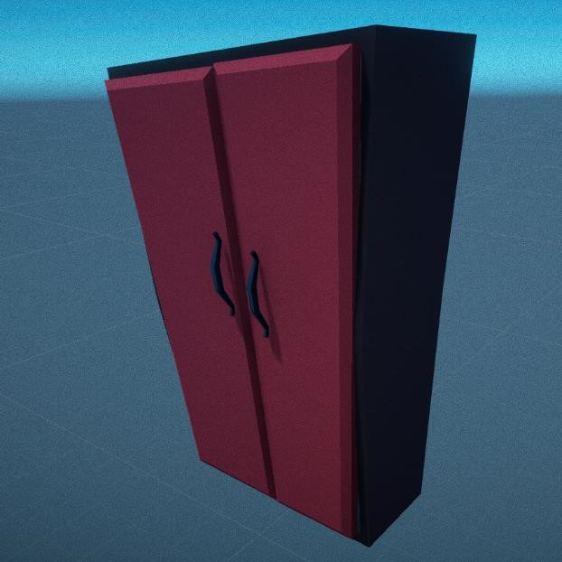 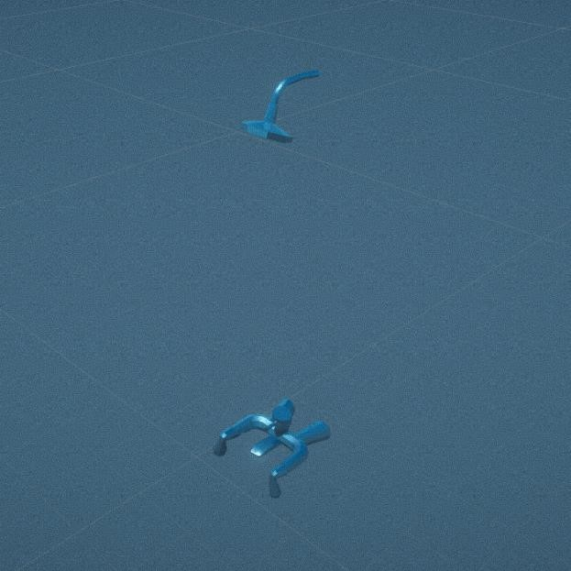

Name: wardrobe Name: Shower and tap

Levels used in: L1, L2, L3 Levels used in: L1, L2, L3

Type: Intractable Type: non-Intractable

Colour pallets: L1, L3, L2 Colour pallets:  L1, L2, L3



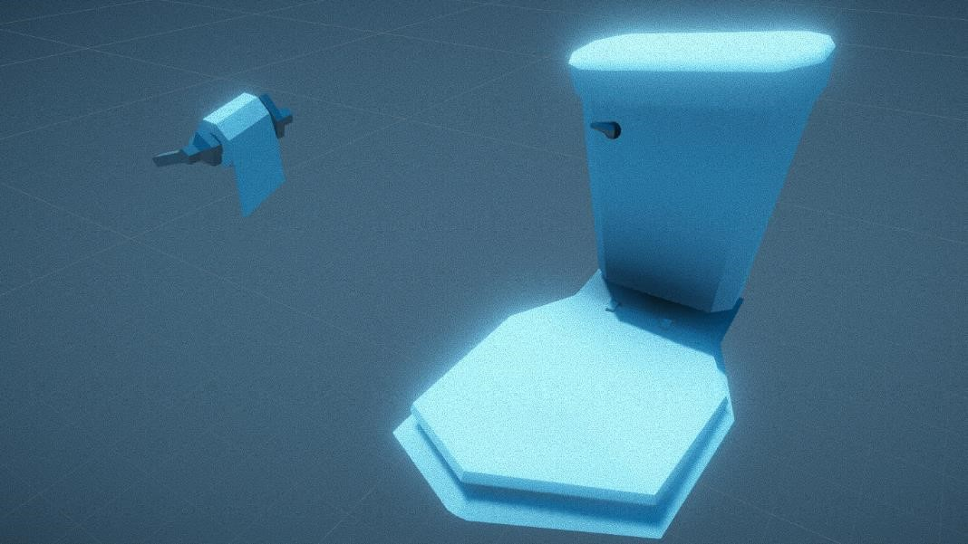

Name: toilet seat

Levels used in: L1, L2, L3

Type: Intractable

Colour pallets:  L1, L2

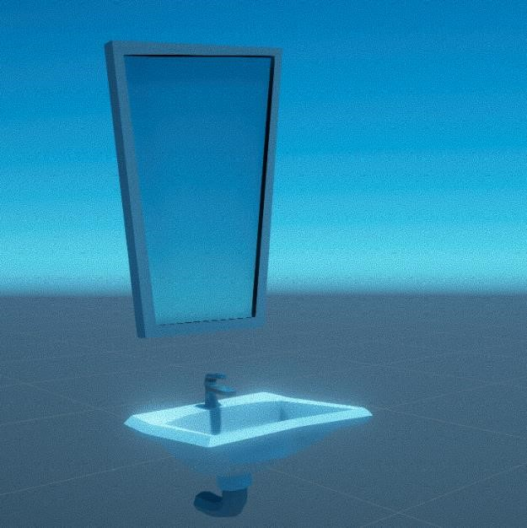 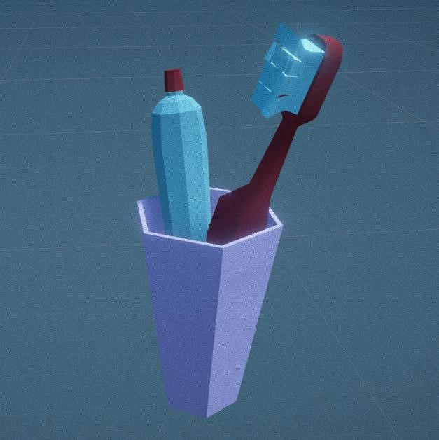

Name: Sink and Mirror Name: Tooth brush kit

Levels used in: L1, L2, L3 Levels used in: L1, L2, L3

Type: non- Intractable Type: non-Intractable

Colour pallets:  L1, L2, L3 Colour pallets:  L1, L2, L3

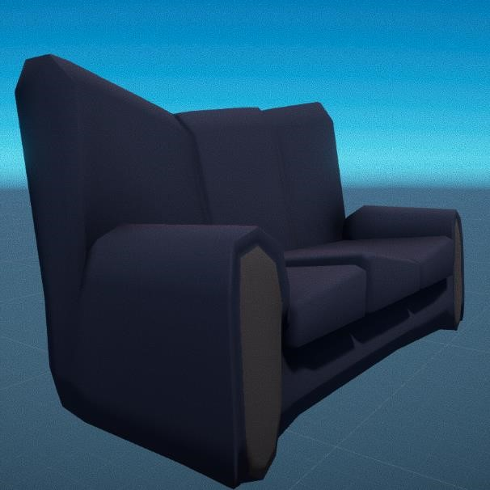 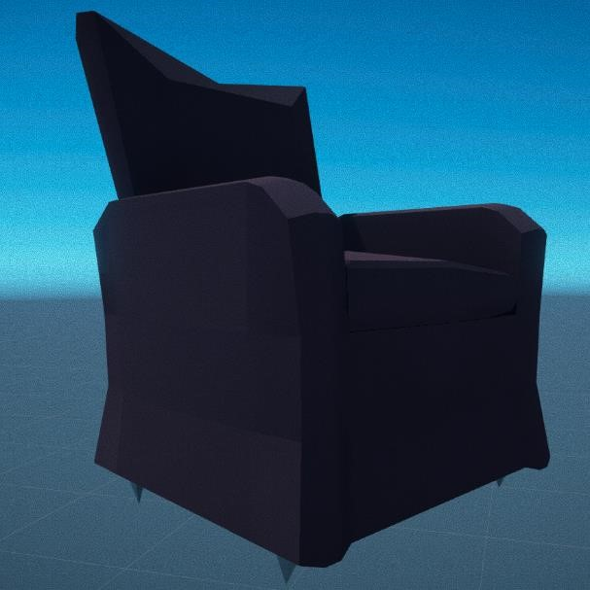

Name: Sofa Name: Chair

Levels used in: L1, L2 Levels used in: L3 Type: non- Intractable Type: non-Intractable

Colour pallets: L1 L2 Colour pallets: L3



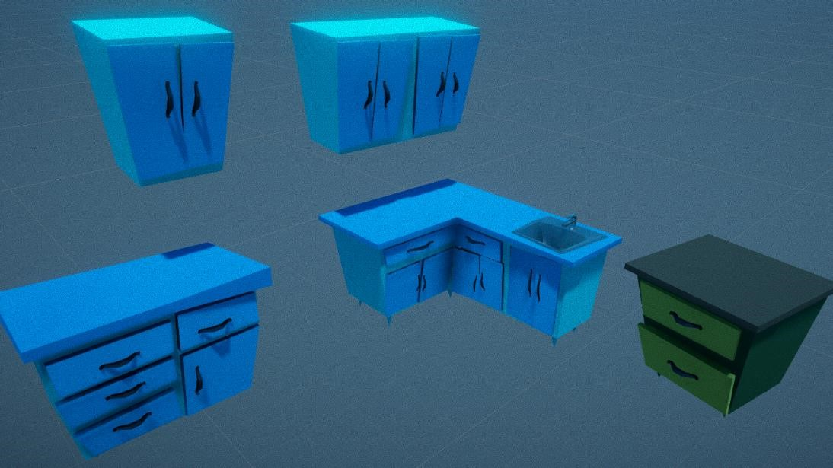

Name: Drawers and shelves

Levels used in: L1, L2, L3

Type: Intractable

Colour pallets:  L3

L1

L2



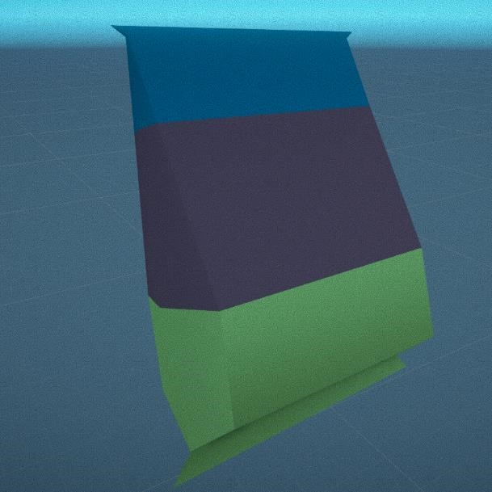 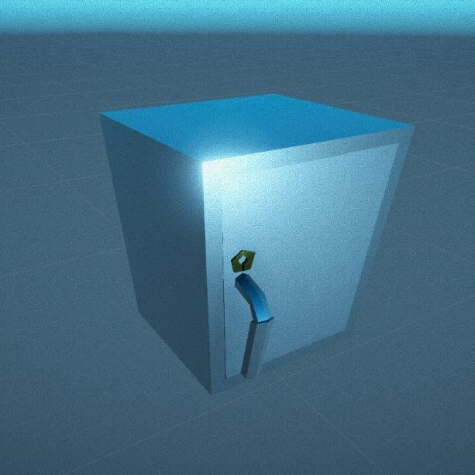

Name: chips Name: Locker

Levels used in: L1, L2 Levels used in: L2

Type: Intractable Type: Intractable

Colour pallets:  L1, L2 Colour pallets:  L2

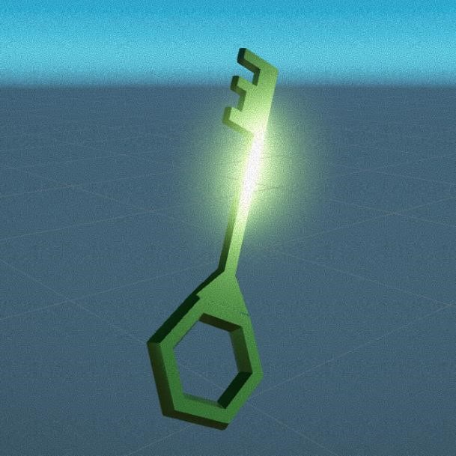 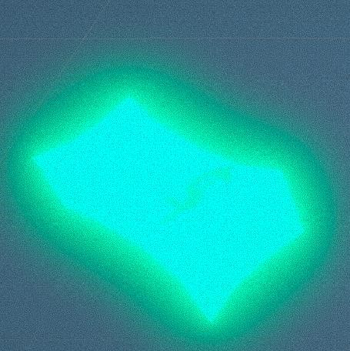

Name: Key Name: Money

Levels used in: L1, L2 Levels used in: L1, L2, L3

Type: Intractable Type: Intractable

Colour pallets:  L1, L2 Colour pallets:  L1, L2, L3

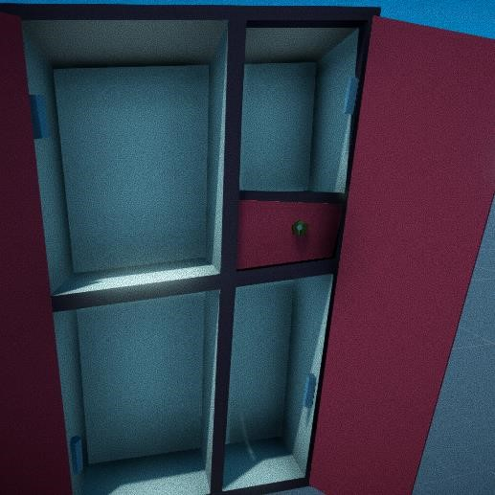

Name: Locker inside wardrobe

Levels used in: L1

Type: Intractable

Colour pallets:  L1, L2

# Mechanics: -

Some of the main mechanics in the game are:

Picking up objects: In the game the player can pick up certain objects which shows the a “press E to interact” popup when the cross hair is aimed to the object and can throw them in any direction he wants.

Opening the cupboards and drawers: The player can interact (open or close) the drawers, cupboards and doors by pressing “E” when “press E to interact” is displayed.

# NPC AI and mechanics: -

Getting Distracted: The NPC will get distracted form what he is doing (sleeping, watching TV) when the player throws anything. The NPC will go to the place where the object thrown by the player collides or falls, will pick it and places it where it used to be in the start and returns to the what he was doing in the beginning.

Detecting the player: The NPC detects the player and “U R Caught” screen will be displayed if the player enters the field of vision of the enemy. Post processing effects: -

The achieve quality output a post processing plugin called “post processing stack” is used. This plugin is available for free in Unity assets store. This plugin will allow the user to control post processing effect like anti-aliasing, ambientocclusion, field of depth, motion blur etc. with will increase the rendering quality of the game.

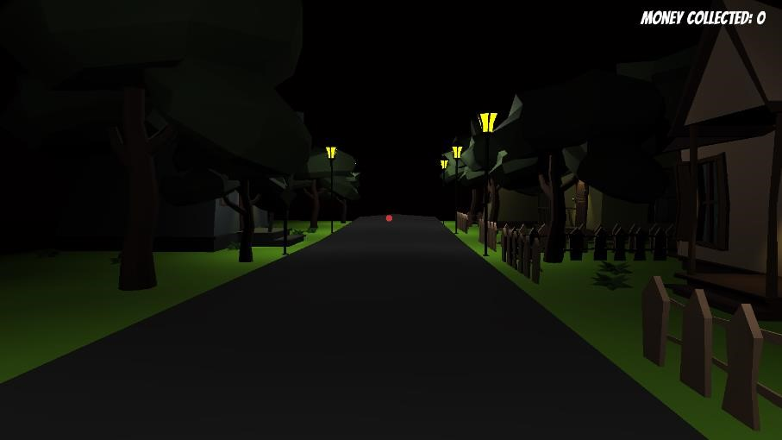

Screenshot before adding “Post Processing Stack”

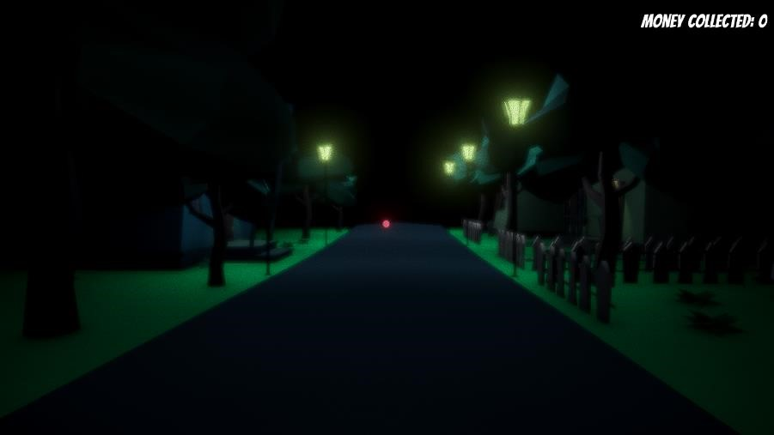

Screenshot after adding “Post Processing Stack”

# Application Development: -

Engine Used: The game is developed using “Unity” and C# script



Image: Unity logo source[: unity3d.com](http://www.google.com/)

Art tools Used: Autodesk Maya is used to model, skin, rig and texture the assets in this game.



Image: Maya logo source: animationkolkata.com

# Code Snippets: -

Cam Scrip:

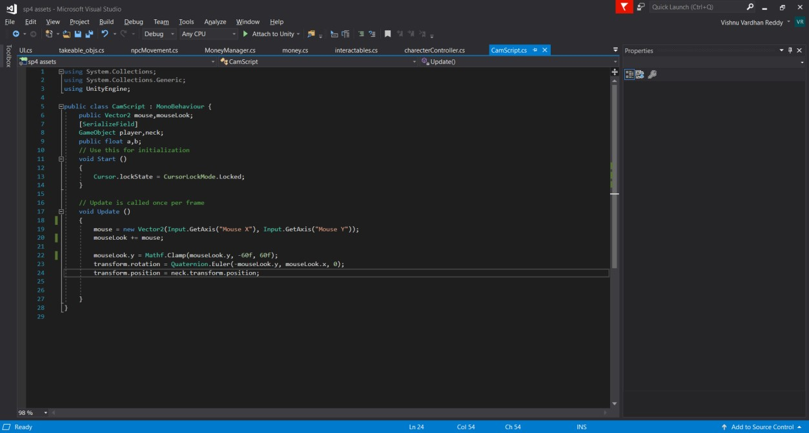

Character Controller:

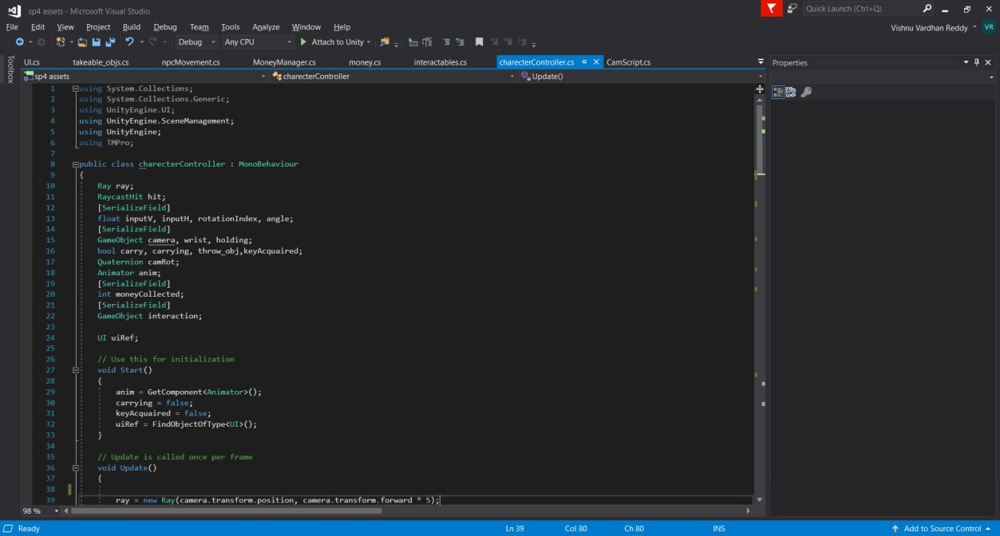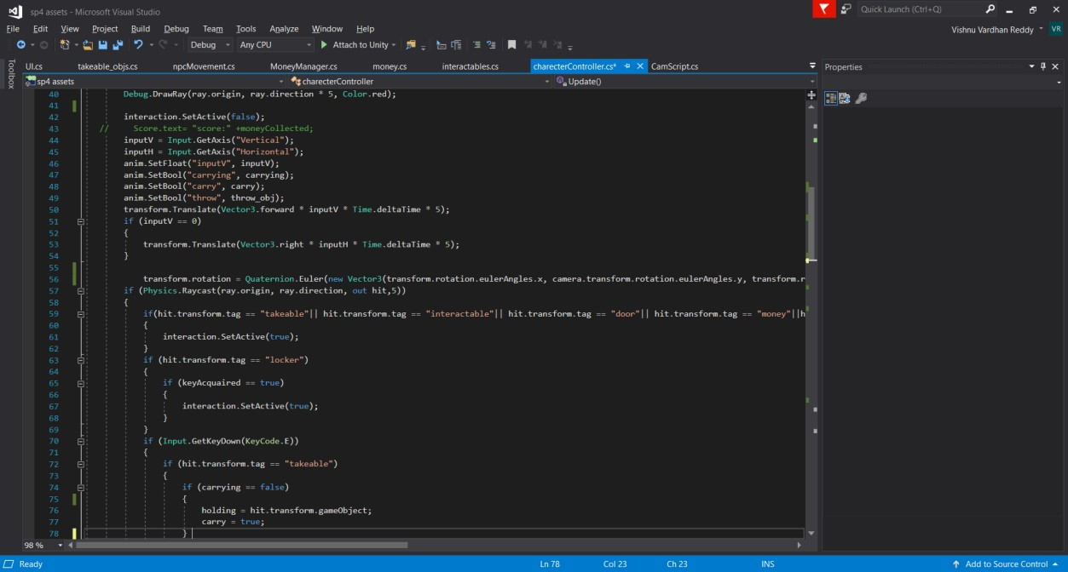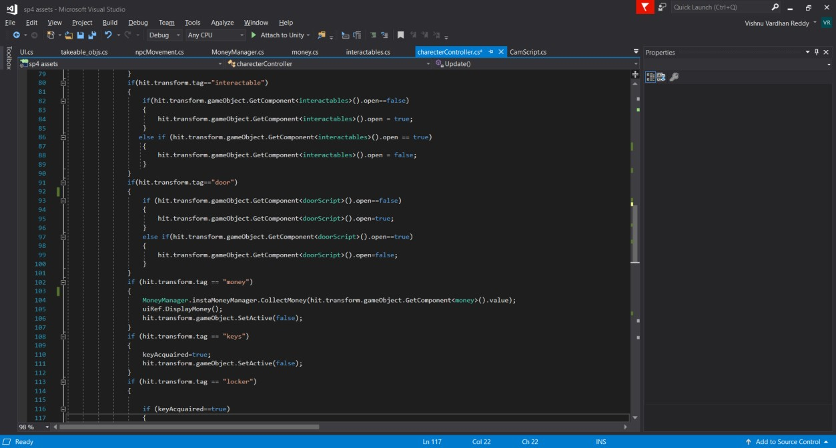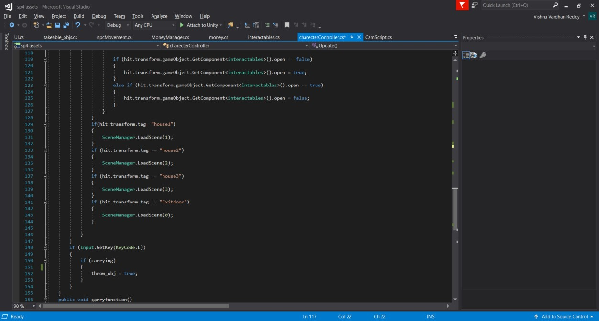

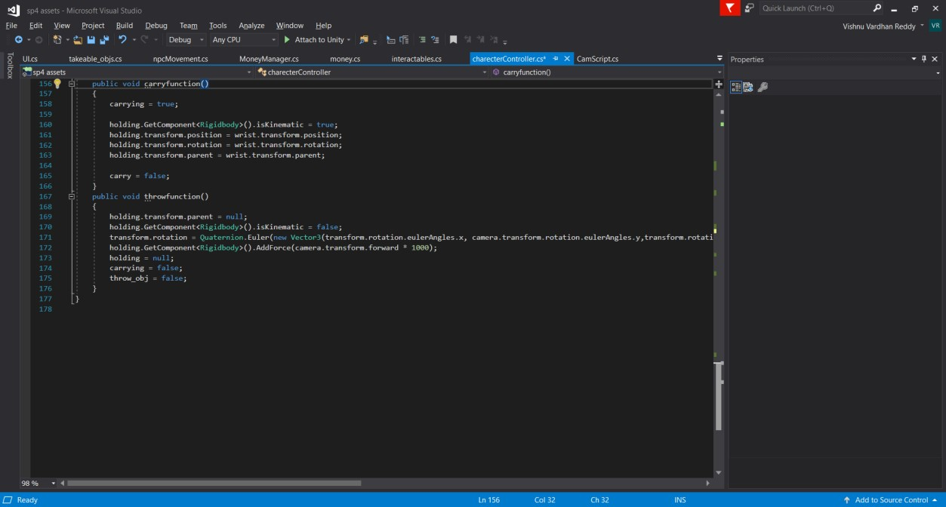

NPC Controller:

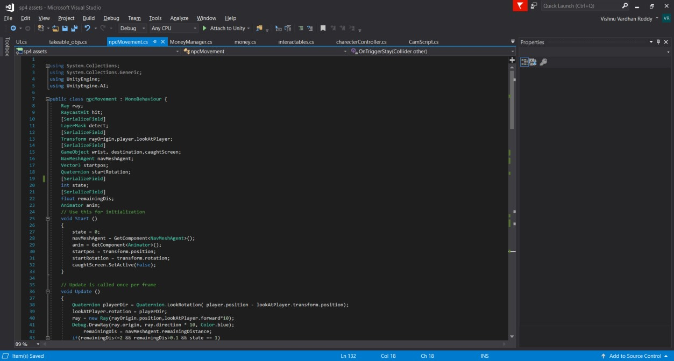

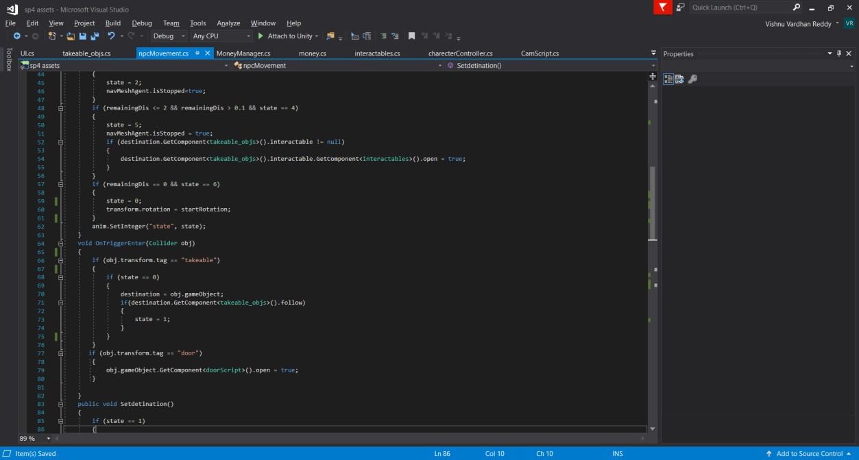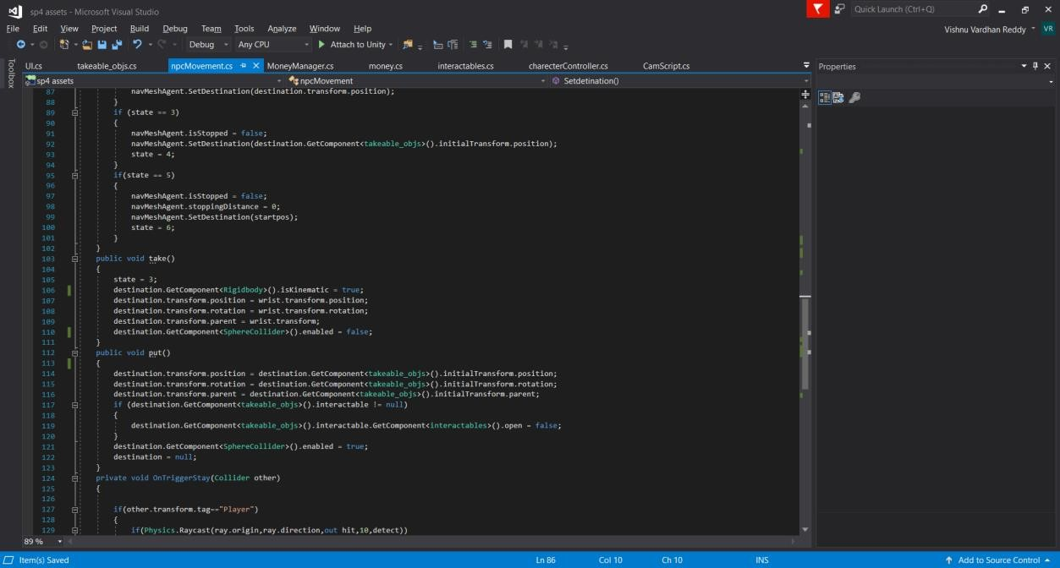

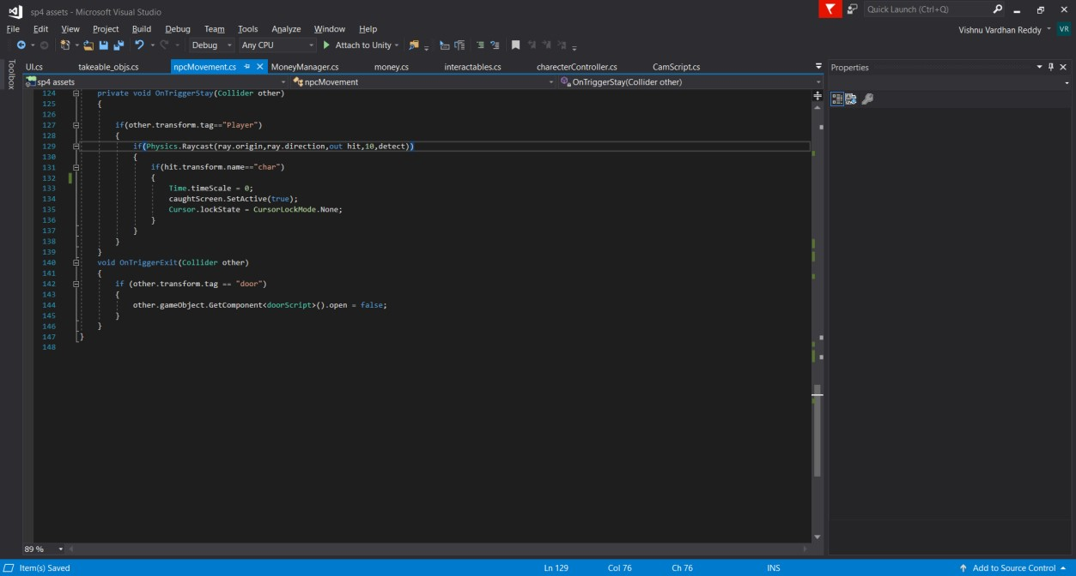

Take able objects:

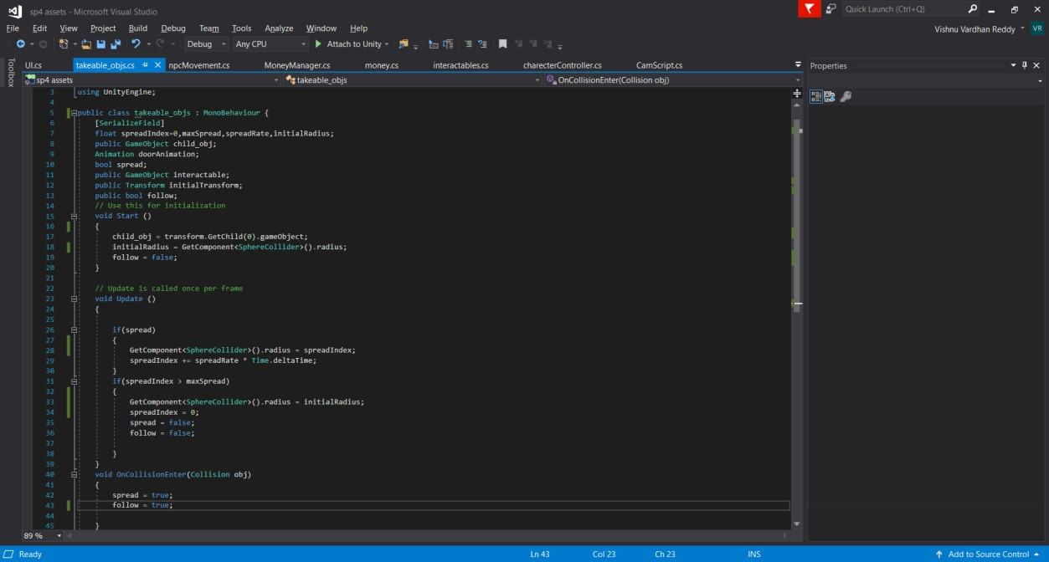

Intractable:

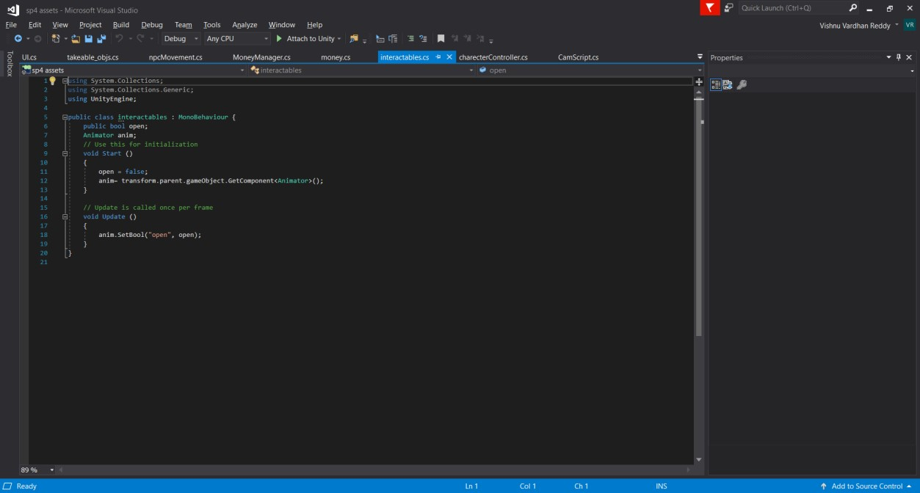

Money Manager:

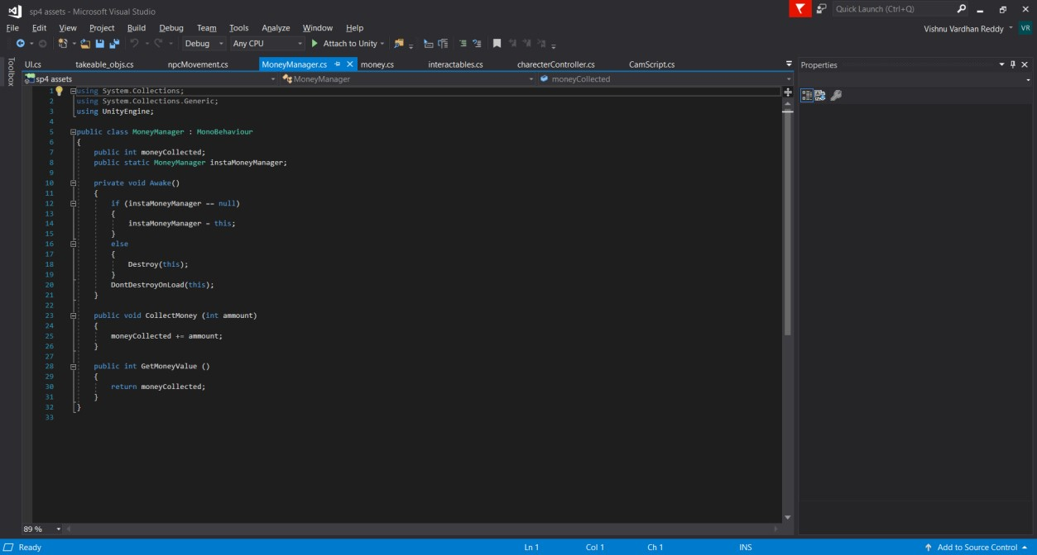

UI:

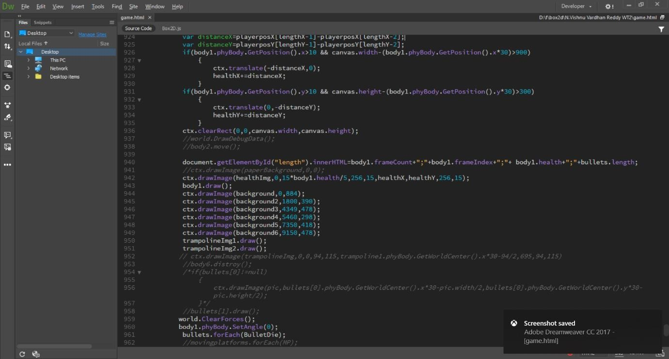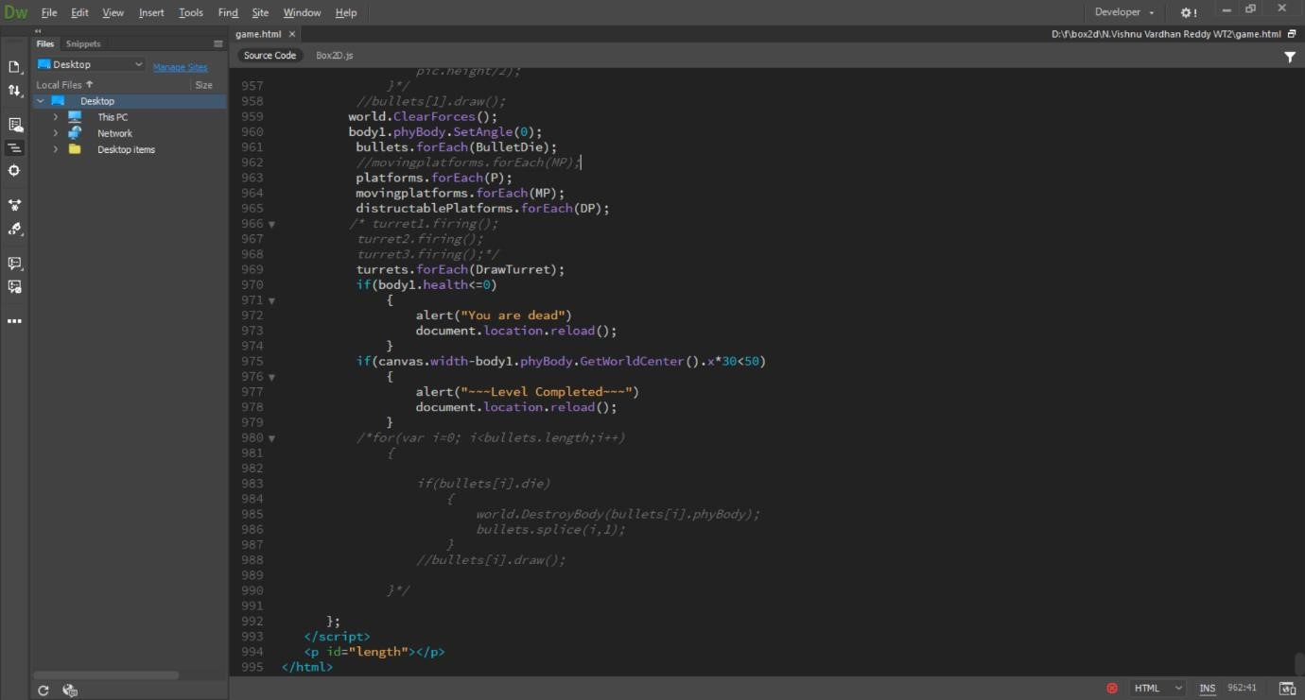

# Game Screenshots: -

